NG18 Khwai Private Reserve
2024 Monitoring Report


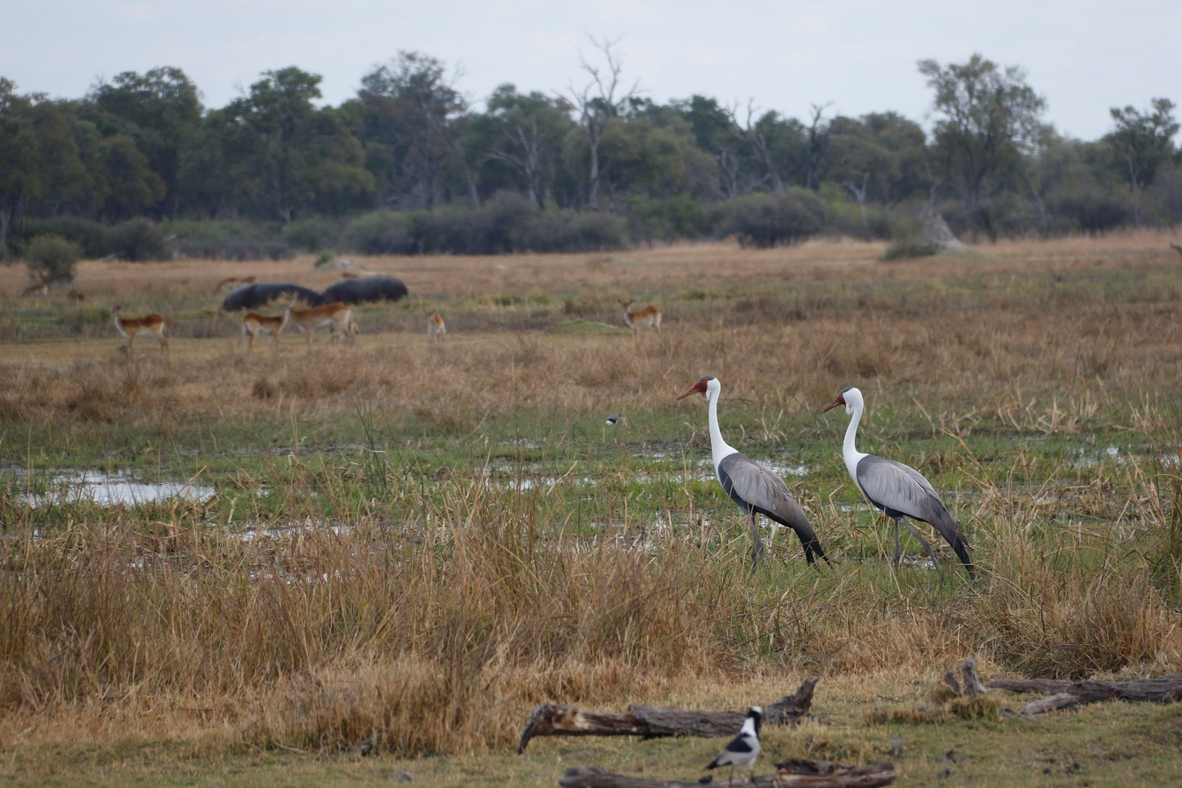



Contents
Summary 3
Introduction 3
Methods 3
Rainfall, flow, and flooding 3
Broad-based bird surveys 3
Waterbird surveys 3
Herbivore surveys 3
Camera traps 3
Analysis 3
Freshwater invertebrate sampling 3
Results and Discussion 3
Rainfall, flow, and flooding 3
Broad-based bird surveys 3
Waterbird surveys 3
Herbivore surveys 3
Camera traps 3
Analysis 3
Freshwater invertebrate sampling 3

Summary
TODO

Introduction
The Okavango Delta is a biodiverse wetland in the North West district of Botswana. The Okavango Delta covers almost 40,000 km² and consists of the panhandle region (Fig. 1), a meandering river system surrounded by permanent swamps, and a large, flat alluvial fan. It is listed as a Ramsar wetland of international significance (Ramsar, 2021), and was designated as a UNESCO world heritage area in 2014 (UNESCO, 2024). The Okavango Delta’s flows originate in the Angolan highlands which feed the Cuito and Cubango rivers. The Cuito and Cubango merge to form the Okavango in southern Angola, before crossing into Namibia, and finally Botswana, where the water disperses into an alluvial fan, inundating the Okavango Delta floodplain (CITE). Flooding in the Okavango is annual, and the floodplain can expand up to three times its permanent size during flooding events, which occur during the dry season (June-August) because of the distance from the headlands to the floodplain (CITE multiple).
The wetland ecosystem of the Okavango Delta is driven by the variable flooding regime that forms a heterogeneous mosaic of wetland types, including permanent rivers, semi-permanent rivers, floodplains, and lagoons (Moliner Cachazo et al., 2023; Mosepele and Mosepele, 2021). The mosaic of
the Okavango Delta is lined by seasonal swamps, whose inundation varies depending on the amount of water feeding the system that year (Gumbricht et al., 2004). Variatiions in flood frequency, duraton, and extent creates a mosaic of vegetationincluding permanent rivers and swamps, seasonally flooded grasslands, dry grasslands, riverine woodlands, and dry woodlands (Ramberg et al. 2006, Milzow et al. 2009). The resultant complex and dynamic ecosystem supports one of Africa’s greatest concentrations of wildlife. There is a commitment to managing the Okavango Delta within a basin context, but there are inevitable scale challenges with this context in relation to different decision-making structures (Motsumi and Cassidy 2012). The delta supports 444 species of birds, 122 species of mammals, 97 species of rep􀆟les and amphibians, and 1300 species of plants (Ramberg et al., 2006). Many of the bird species are waterbirds with breeding of many dependent on increasing flows and flooding and riparian woodlands (Francis et al. 2021).

The Khwai Private Reserve (KPR; NG18 concession) is a large (~2000km2) wildlife management area (WMA) west of Khwai village in Ngamiland District in northern Botswana. It is adjacent to the Moremi Game Reserve and due west of the southwestern boundary of Chobe National Park. The Khwai River flows through the area, supporting large concentrations of wildlife, including herbivores such as impala (Aepyceros melampus), waterbuck (Kobus ellipsiprymnus), zebra (Equus quagga), reedbuck (Redunca fulvorufula), tsessebe (Damaliscus lunatus), hippopotamus (Hippopotamus amphibius), Cape buffalo (Syncerus caffer), and African bush elephant (Loxodonta africana) (Burger 2020). These and other species also support an intact large carnivore guild, comprising of African wild dog (Lycaon pictus), lion (Panthera leo), leopard (Panthera pardus), cheetah (Acinonyx jubatus), and spotted hyaena (Crocuta crocuta). The area is characterized by a variety of habitat types, including floodplain grasslands, riverine forests, mopane and other woodlands, permanent swamps and savanna and scrub, and has a number of tourist camps spread throughout.
Tracking ecosystem health requires standard periodic surveys. Fauna presence and abundance varies annually, seasonally, and between specific areas, according to resource availibility. Obtaining consistent and precise data from surveys within such a dynamic system presentes challenges in replication, given changes in accessibility due to shifts in flooded areas and extents. As part of a university course “River Basin Ecosystem Management”, students and staff from the University of New South Wales (Australia), Arizona State University (United States) and Kings College London (United Kingdom) and University of Botswana, with the support of Natural Selection, conduct annual biodiversity surveys within the Khwai Private Reserve, .This report describes the methodology and examines the results of these surveys, including a comparision to the first year (2023).

Methods

Rainfall, flow, and flooding
We obtained rainfall, flooding, and flow data for the entire Okavango Delta and KPR. Annual cumulative precipitation for the Okavango Delta was determined using the Climate Hazards Group InfraRed Precipitation with Station data (CHIRPS) (Muthoni et al. 2019, Shen et al. 2020), which combines satellite imagery and ground station data to create a rainfall time series with a resolution of 0.05° from 1980-2024. We obtained water level data for the Okavango River at Mohembo to track recent (2018-2024) monthly and annual flow pulses to the Okavango Delta. We also estimated maximum annual (1988-2024) inundation extent (July-September) when flooding was most widespread, across the Okavango Delta study area using Landsat 5,7 and 8 rasters, based on a short-wave infrared threshold, as developed by Inman and Lyons (2020).

Broad-based bird surveys
eBird is a global citizen science project that collects data on bird communities, comprising one of the largest biodiversity projects in the world (CITE). We recorded eBird observations (CITE) while at KPR, both at camp and during surveys. Each day, one individual recorded the identities and count of each species observed, including terrestrial and waterbird species. The location and time of each observation was also recorded. The final eBird list documents the diversity and abundance of all bird species observed on KPR during the trip, including birds detected during formal surveys (see below) and at other times while present in KPR.

Waterbird surveys
We conducted waterbird surveys on three days (02-04 JUL 2024) between 11:00 and 15:00, from three points on the floodplain (Fig x). Observers identified bird, mammal, and reptile species and recorded their abundance, with care taken to not double count individual species that moved between survey points. For analysis, we separated waterbirds into five functional groups: carnivores, herbivores, insectivores, omnivores, and piscivores (Table Ax). We also classified mammal and reptile species into similar functional groups: carnivores, herbivores, and omnivores (Table Ax). We compared estimates of species richness and abundance to previously collected data from 2023.

Herbivore surveys
We conducted vehicle based terrestrial herbivore surveys over three days (02-04 JUL 2024). Surveys were conducted daily between 0800-1330 by two expert observers and between four and six student observers, with one person designated as a scribe on each survey. A vehicle was driven at a speed of 5-10km/hr along a predetermined 19.5km circuit, split into two transects characterised by habitat type: ‘mopane’ woodland (12.2km) and generally dry ‘floodplain’ (7.3km) (Fig x). Observers were stationed on each side of the vehicle facing opposite directions, and continuously scanned for mammal species on either side of the vehicle and were assisted in spotting by the vehicle’s driver/guide. When an animal was spotted, the vehicle was stopped, and data were collected by the whole team. Data were collected for all large mammals and some small mammals. We collected species, count, distance from the vehicle (using a Nikon laser range finder), bearing from the vehicle, and demographic information of each individual (sex, broad age categories [adult, subadult, juvenile]) where possible. The GPS coordinates of each sighting were also record, along with the odometer reader (the distance along the transect). This information was relayed to the scribe, who recorded it on a datasheet.

Camera traps
Three Bushnell camera traps were rotated between four sites and collected still images to capture animal use of bridges. Cameras were collected at the end of the trip, and all captured images were manually reviewed for the presence of species.

Invertebrate sampling
To detect and quantify any differences in ground-dwelling invertebrate biodiversity and richness resulting from wildfires, we established two sites in grassy areas that were burnt in September 2023. We paired these with control sites that were unburnt at that time or other times leading up to the survey period. ￼￼￼At each site, we set out eight pitfall traps in a roughly linear transect and revisited sites after approximately 24 hours, identified and counted invertebrates, and reset the traps. The traps were surveyed twice over a four-day period. We classified invertebrates into five morphotypes (ant, beetle, spider, fly, termite), but did not identify specimens to a species level.

Analysis
Data were collated and analysed in R (R Core Team, 2024) to determine species diversity and abundance of birds, mammals, amphibians, and reptiles. Results from 2024 were compared with those from 2023.
For waterbird surveys, species abundance and richness were calculated for each survey site, and for all survey sites combined. Species abundance and richness for each functional group were also calculated.

For herbivore survey data, we calculated overall species richness and abundance for both habitats (‘mopane’ and ‘floodplain’, Fig x), and compared species richness and abundance for different orders (Artiodactyla, Carnivora, Perissodactyla, Primates, Proboscidea, Rodentia, Struthioniformes). We also used the Distance package (CITE) to estimate a single Detection Function for each species in each habitat and calculated the density of each species in each habitat. Overall densities (both habitats combined) were used to estimate the abundance of each species across the entire KPR (~2000km2).
We compared the effects of burning on invertebrate abundance and richness using a generalised linear mixed model, fit with the ‘glmmTMB’ package (Brooks et al., 2017). The model for species richness used a Gaussian family with an identity link, and the model for species abundance used a negative binomial family with linear parameterisation and a log link. Both models included date and treatment as fixed effects, and replicate as a random effect. Assumptions were checked using the ‘performance’ package (Lüdecke et al., 2021).

Results and Discussion

Rainfall, flow, and flooding

Rainfall in the Okavango Delta
Cumulative annual rainfall in the Delta was the lowest on record since 1980. It was lower than 2023 rainfall, and was over 200mm lower than the long term average (Fig x). This was reflected in the dry conditions in Khwai Reserve during wilflife surveys.
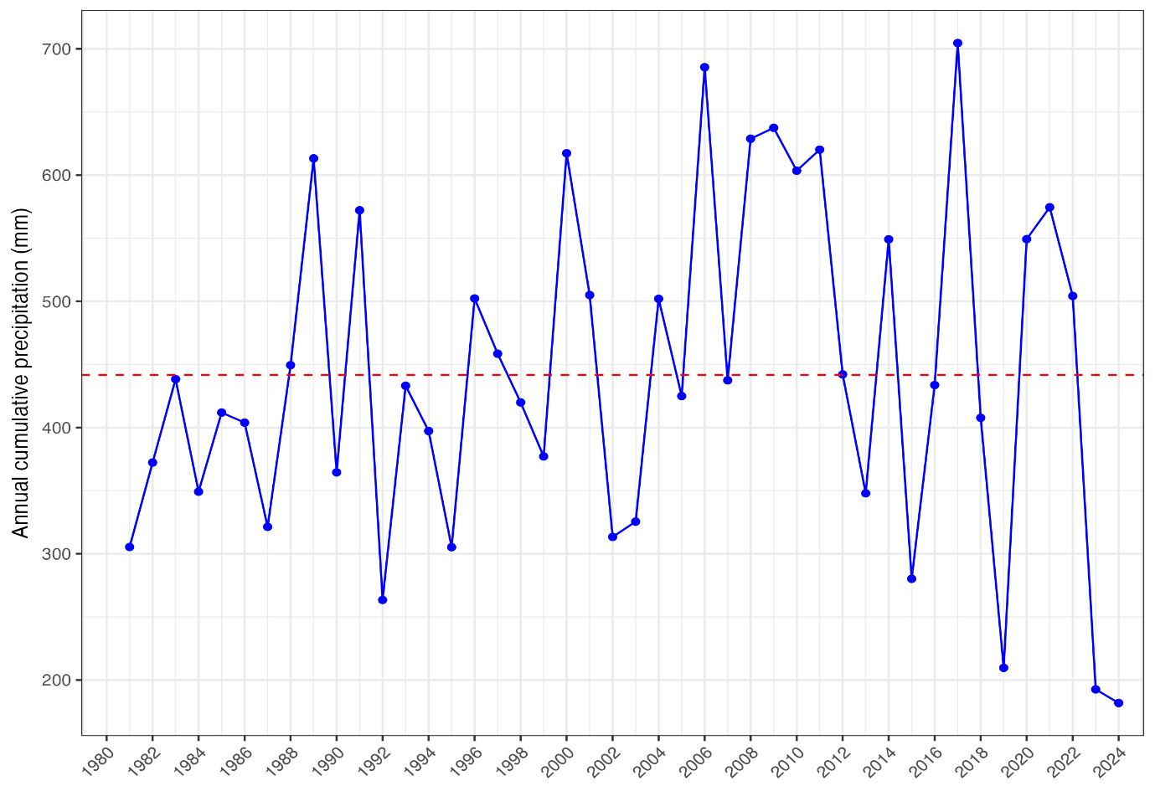

Flow in the Okavango River
The water level of the Okavango River at Mohembo was the second lowest in five years (2019-2024), and held at a constant level in comparison to previous years, which often have two peaks (Fig x)
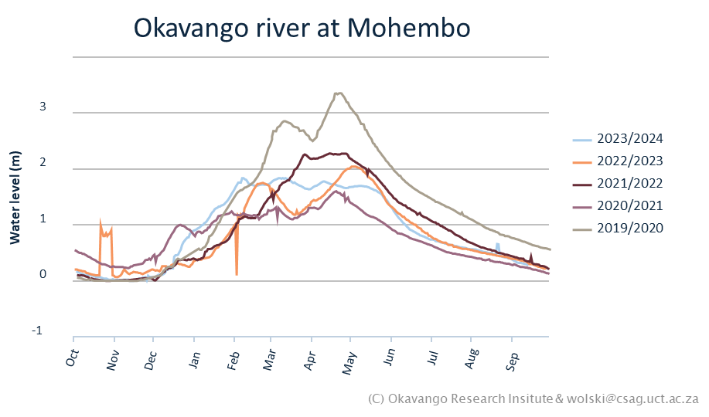

Flooding in the Okavango Delta
Flooded area in 2024 was lower than 2023, with approximately 4375km² inundated, which is relatively low in comparison to floods recorded 1988-2023 (Fig x). All floods in the last five years have been below the overall median of 6250km², but this is the lowest, reflecting the low flow recorded upstream (Fig x). This is apparent in a comparison of 2024 flooding and flooding during a recent high flood event (2011) across the whole Delta (Fig x), and also in Khwai Reserve, with less land inundated in 2024 compared to 2011 (figs x & y).
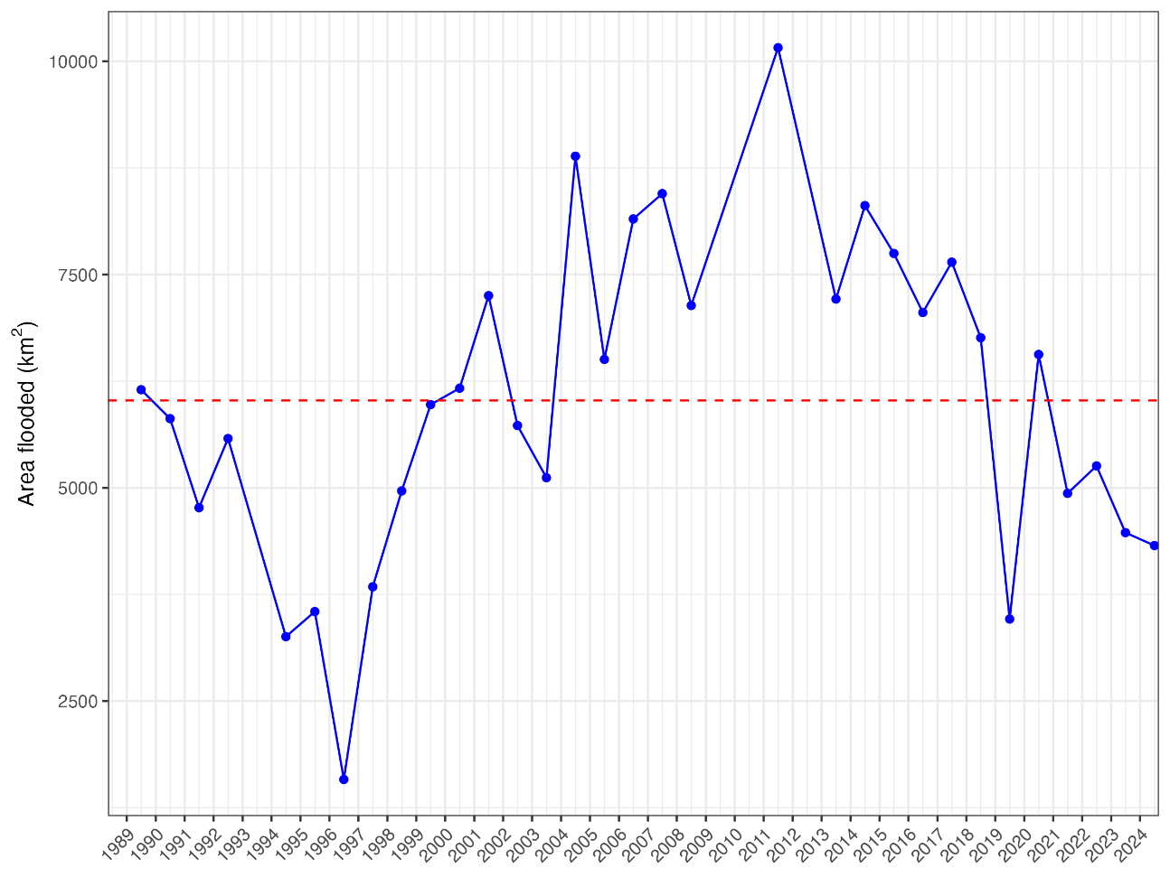
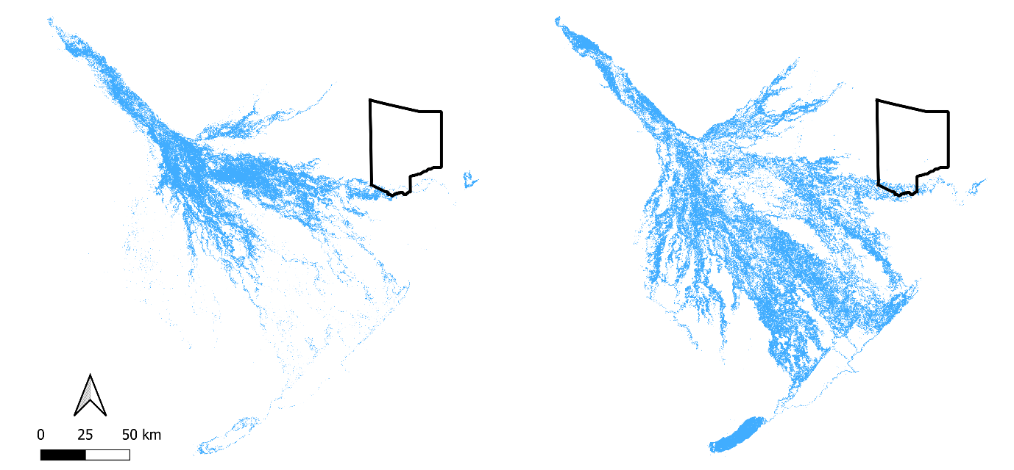
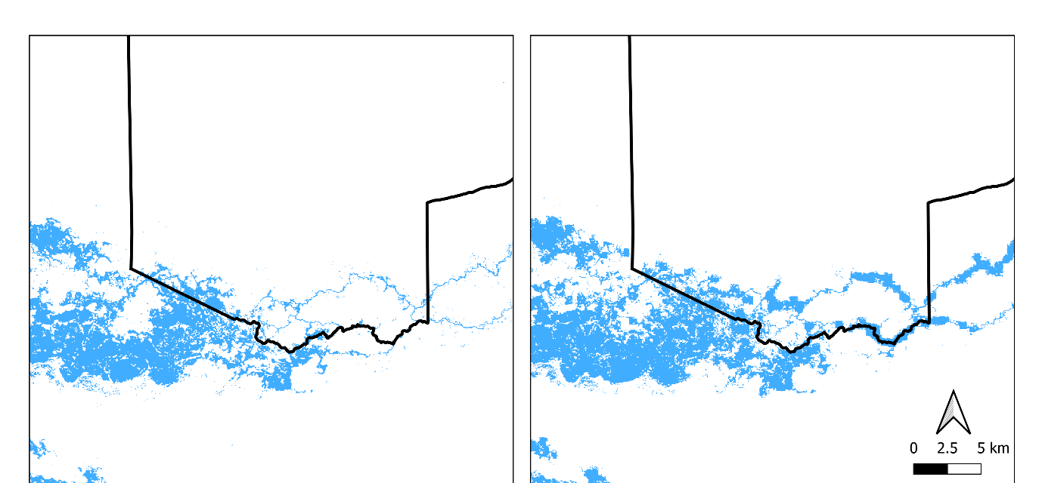

Broad-based bird surveys
We observed 62 bird species in 2024 (1st – 5th July) (Table Ax). The lists for each day are provided on eBird (LINKS). Pink backed pelican, helmeted guineafowl, and red-billed spurfowl were the most common species observed.

Waterbird surveys
We observed 45 bird species during our surveys, including 20 carnivore, one herbivore, eight insectivore, six omnivore, and six piscivore species (Table Ax). Total species richness was 27 at site A, 30 at site B, 21 at site C, and 45 for all sites (Fig x). Total species abundance was 111 at site A, 137 at site B, 70 at site C, and 318 for all sites (Fig x). Mean daily species richness was highest at site B (15 species), then site A (14 species), with lowest richness at site C (10 species). Overall mean species richness was 25 species (Fig x). Mean daily abundance was highest at site B (45 individuals), then site A (37 individuals), then site C (23 individuals). Overall mean species richness was 106 individuals (Fig x). Total species richness for all sites was slightly lower in 2024, but mean daily species richness was slightly higher (Fig x). Total species abundance was higher in 2024, as was daily mean species abundance (Fig x).
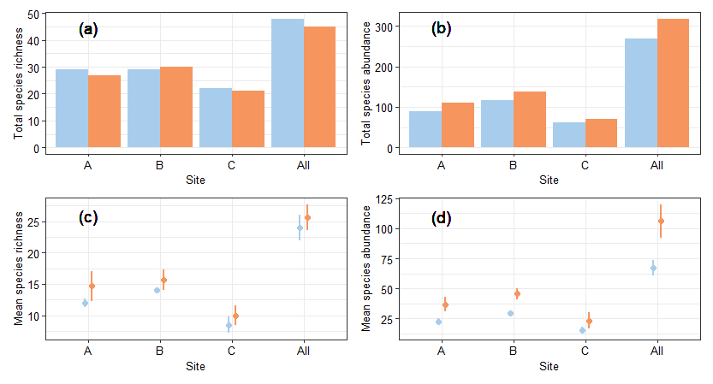
We separated waterbirds into functional groups (Table Ax). The highest median abundance and richness was for carnivorous birds (Fig x), as was the highest maximum species richness and abundance (Fig x), probably reflecting high productivity in the ecosystem. Herbivore richness and abundance was lowest, with other functional groups falling in-between these two groups (Figs x, y). Species richness as abundance was higher in 2024 than in 2024 for all groups except for herbivores, which had lower species richness, and piscivores, which had lower species abundance (Fig x).
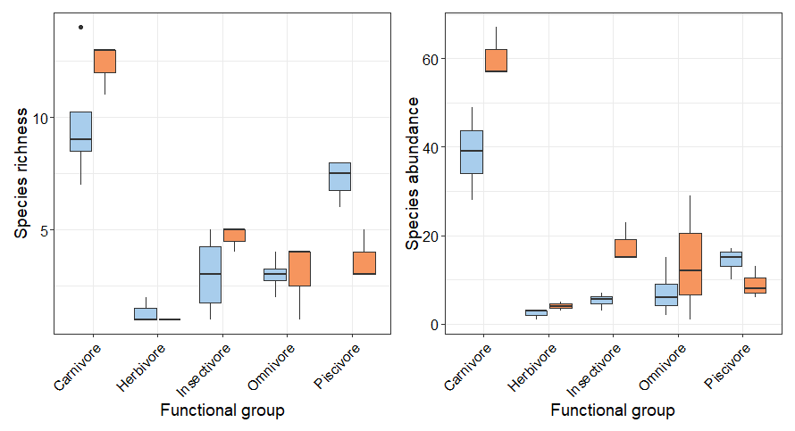
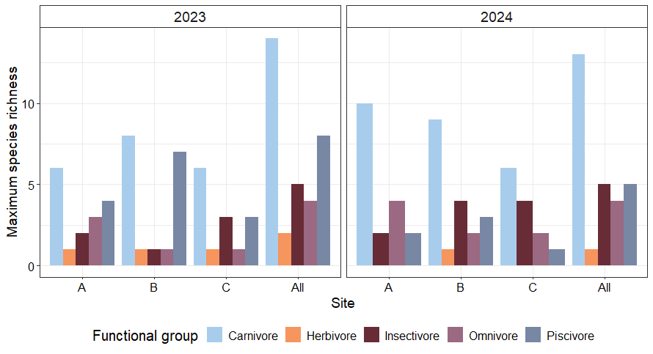

During waterbird surveys, we identified and counted all other vertebrate species (mammals and reptiles) either on the river or in riparian areas. Herbivores had the highest species richness and abundance (mostly impala and red lechwe). Carnivores had the next highest species richness, but omnivores had the next highest species abundance (Figs x & y).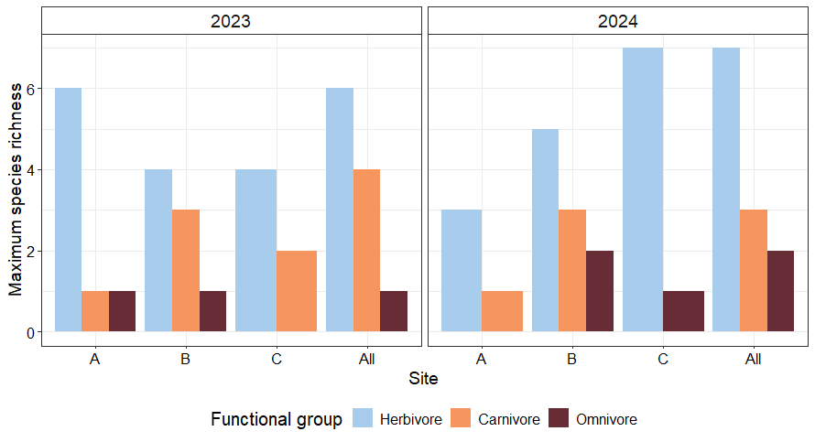
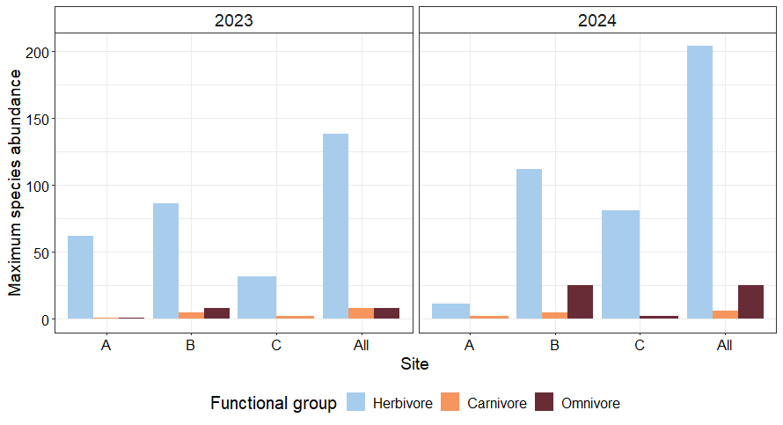
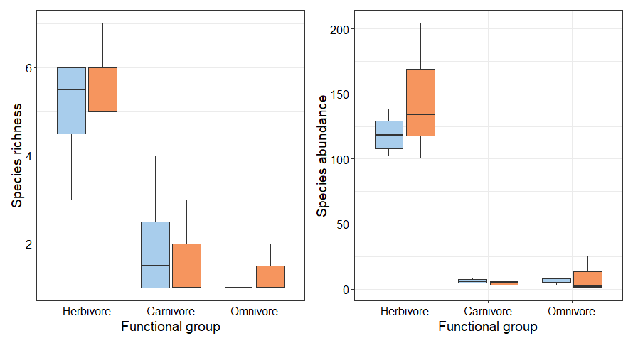

Herbivore surveys
We detected 13 species across six transects (three ‘mopane’, three ‘floodplain’), three less than in 2023 (Fig x). ‘Mopane’ transects had higher total species richness, but ‘floodplain’ transects had higher total species abundance (Fig x), higher median daily species richness, and higher median daily abundance (Fig x). Total species richness and median daily species richness was lower in 2024 than in 2023, Total abundance was slightly higher in 2023 than 2024, but median daily abundance was higher in 2024.
The functional group with the highest species richness was Artiodactyla, which also had the highest overall species abundance (Fig x), mostly because of high impala abundance (Fig x, Table Ax). However, in ‘floodplain’ transects, Perissodactyla had the highest abundance (Fig x), driven by high zebra abundance (Fig x, Table Ax).

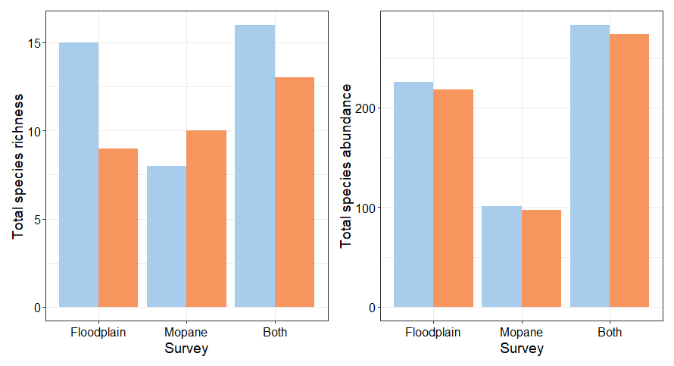
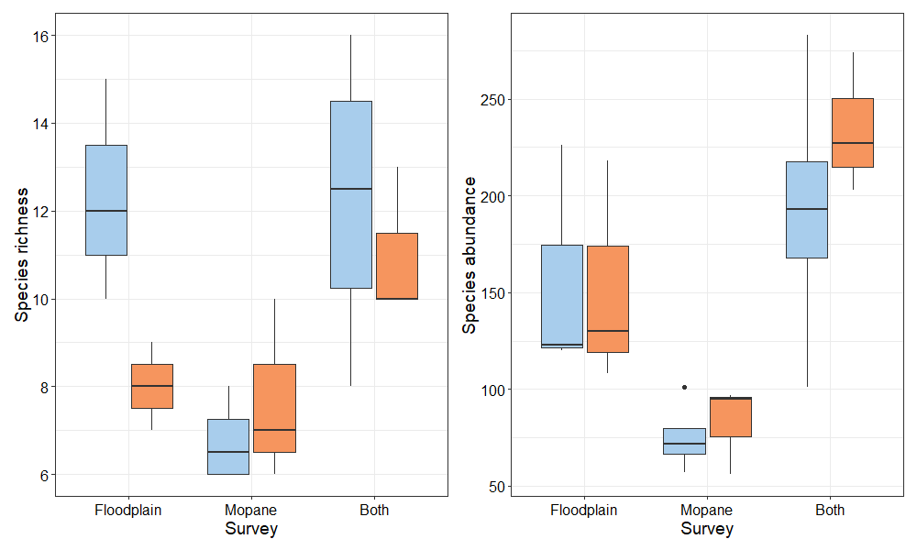

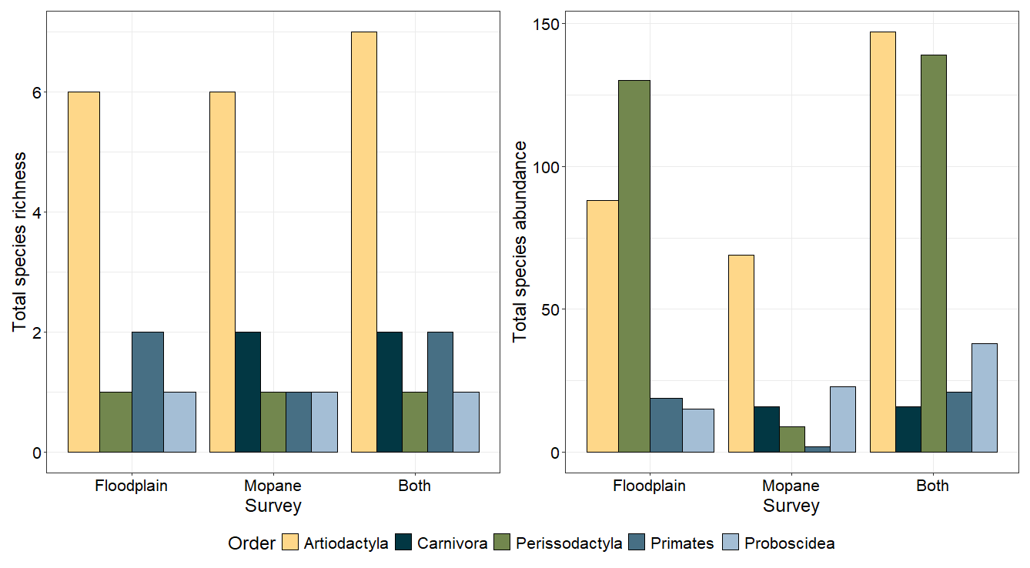
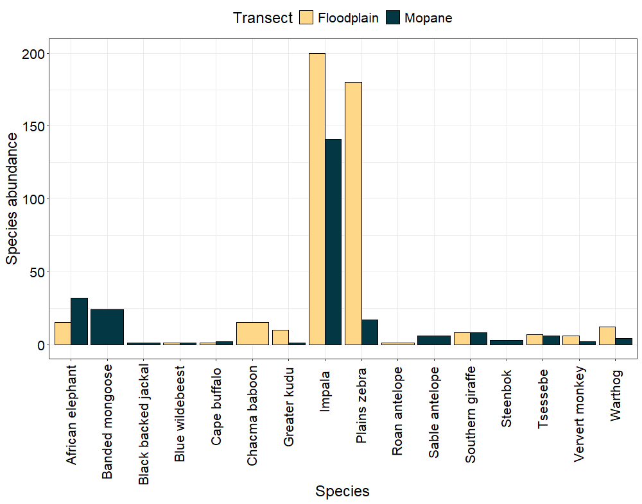

We estimated the density of detected mammal species based on transect distance sampling (Table 1). This method is not suited to species that are wide ranging, or rare species that are only sporadically detected, such as buffalo or sable. These species are included in the analysis but are marked with a “*”.
Common name | Scientific name | Density (SE) | Abundance
Carnivores
Black backed jackal | Lupulella mesomelas | 0.13 (11905.28) | 222.53
Banded mongoose | Mungos mongo | 14.9 (11.37) | 26073.98
Herbivores
Impala | Aepyceros melampus | 25.22 (14.19) | 44129.75
Blue wildebeest | Connochaetes taurinus | 0.11 (9147.35) | 191.58
Tsessebe | Damaliscus lunatus | 0.56 (0.63) | 974.17
Plains zebra | Equus quagga | 9.69 (11.29) | 16962.83
Southern giraffe | Giraffa camelopardalis | 1.15 (0.42) | 2008.78
Roan antelope | Hippotragus equinus | 0.04 (0.16) | 68.23
Sable antelope* | Hippotragus niger | 0.44 (5843.16) | 764.77
African elephant* | Loxodonta africana | 3.58 (0.67) | 6268.44
Warthog | Phacochoerus africanus | 0.94 (0.82) | 1652.83
Steenbok | Raphicerus campestris | 0.38 (0.41) | 667.19
Cape buffalo* | Syncerus caffer | 0.27 (0.14) | 468.25
Greater kudu | Tragelaphus strepsiceros | 0.78 (0.9) | 1369.44
Primates
Ververt monkey | Chlorocebus aethiops | 1.91 (1.79) | 3338.9
Chacma baboon | Papio ursinus | 3.73 (95965.66) | 6531.86

Between 2013-2019, NG18 was surveyed by Round River Conservation Studies and the Okavango River Institute (CITE), focusing on six species with the most sightings. These species were also surveyed by the PLuS Alliance in July 2023. The 2024 survey found higher densities of impala, zebra, and elephant, stable densities of giraffe, and a decline in kudu density (Table x). Higher densities were all within the margin of error, possibly indicating that the observed increase in density is random. The decline in kudu density was also within the margin of error. Given the dry conditions in the delta this year, it also highlights the resilience of mammal populations in NG18.
Common name | Scientific name | Survey | Density | Density SE
Impala | Aepyceros melampus | RR (2019) | 10.32 | 2.05
 |  | PLuS All. (2023) | 23.53 | 0.92
 |  | PLuS All. (2024) | 25.22 | 14.19
Plains zebra | Equus quagga | RR (2019) | 7.23 | 1.01
 |  | PLuS All. (2023) | 6.16 | 0.43
 |  | PLuS All. (2024) | 9.69 | 11.29
Southern giraffe | Giraffa giraffa | RR (2019) | 1.19 | 0.26
 |  | PLuS All. (2023) | 1.15 | 0.18
 |  | PLuS All. (2024) | 1.15 | 0.42
African bush elephant | Loxodonta africana | RR (2019) | 3.22 | 1.4
 |  | PLuS All. (2023) | 2.14 | 0.67
 |  | PLuS All. (2024) | 3.58 | 0.67
Greater kudu | Tragelaphus strepsiceros | RR (2019) | 2.15 | 0.32
 |  | PLuS All. (2023) | 0.6 | 0.11
 |  | PLuS All. (2024) | 0.78 | 0.9

Camera traps
TBC

Invertebrate sampling
Across all locations, a total of 127 individuals (Fig x) were collected across five morphotypes (Fig x). Only four traps did not collect any specimens – three at the burnt site and one at the unburnt site. Both treatments had a maximum richness of five morphotypes, and maximum abundance was higher at the unburned site (41) than the burned site (33).
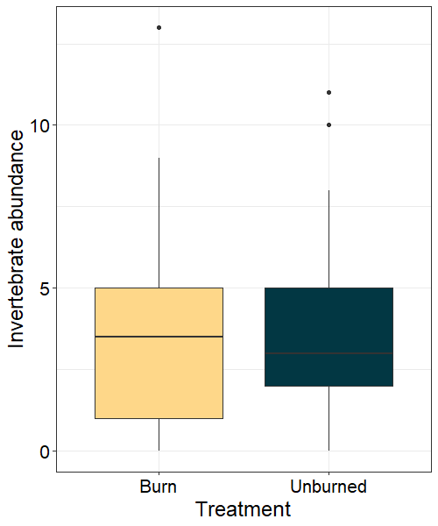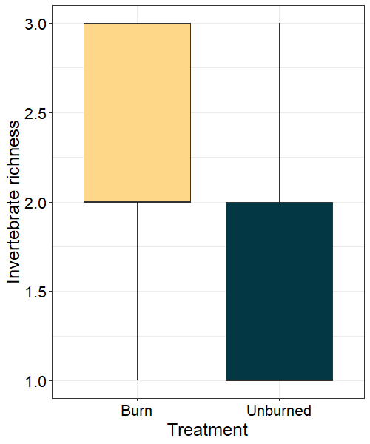
Species richness was significantly higher in burned sites (z = -3.02, p = 0.003), but there was no difference in species abundance (z = 0.15, p = 0.877). Higher species richness in burnt sites is unusual, as burning usually has a negative effect on species richness and abundance because of decreased litter (Day et al., 2019; York, 1999), and could also be explained by site location, proximity to water, and time of year. More frequent monitoring could help understand this result.

Conclusions

